Environmental Conditions and Animal Abundance
Biol 312

Introduction
Low tide exposes the lower reaches of the seashore to our exploration. We can begin to see the environment that organisms interact with and understand how organisms partition space. Today, we’ll look at the distribution of organisms in the intertidal.

Methods
- Spend ~20 minutes exploring the area uncovered by the tides. Systematically explore the factors that appear to determine the abundance of Littorina littorea on rock surfaces and the abundance of Hemigrapsus sanguineus or other crabs on or under rocks. Ask us for species IDs beyond these four below.

Littorina littorea Fucus vessiculosus
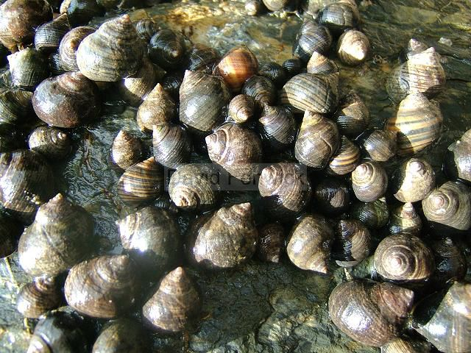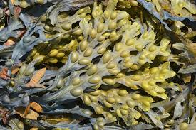
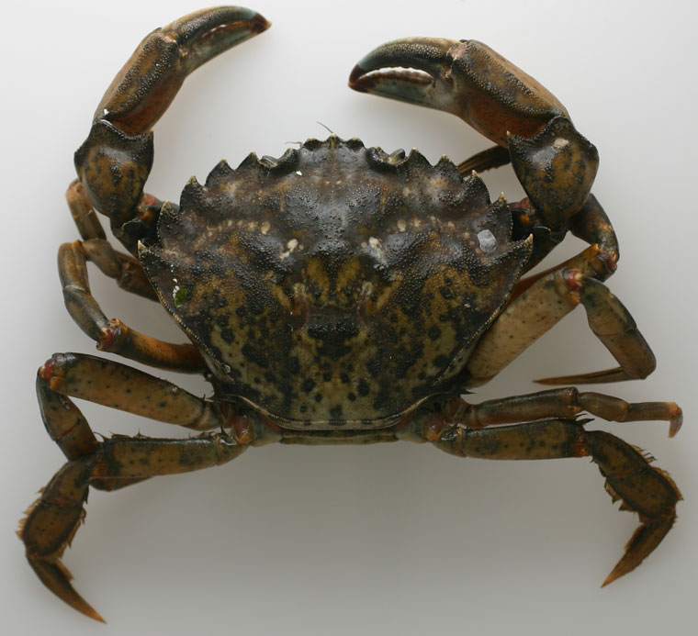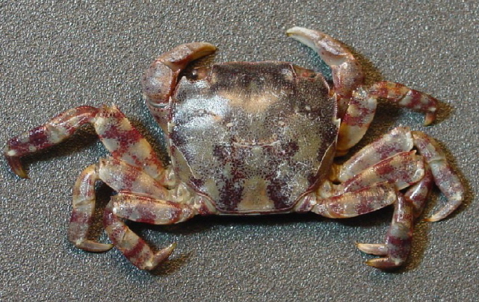

Carcinus maenas Hemigrapsus sanguineus

- Based on your observations, construct a hypothesis about what regulates the abundances of crabs and snails.

- Perform a survey to test your hypothesis observationally. Draw out how you think the system works, and think about our principles of good sampling design – handling confounders, replication, etc. You make take additional measurements with tools provided, such as size of rocks, cover of algae, distance from the high-tide line, etc., if you think them warranted.

- Design a manipulation to try and create habitats according to your hypothesis that, after a few days, should have higher or lower abundances of crabs and snails. Think carefully about your treatment, your control, and your null hypothesis. We will provide paint scrappers, but merely moving about rocks of different types will accomplish much.

- OPTIONAL: If possible, resample your experimental habitats before writing up the lab. Record abundances of crabs and snails. Did your data falsify your null? How would you revise your overall hypothesis based on your observations and experiment?

Analysis and Write-up
Please provide:

- A brief introduction to what you observed. Discuss your hypothesis at length and proffer any alternatives.
- State the methods you used to conduct an observational study and manipulative experiment.
- Provide a narrative discussion of results.
- In the discussion, talk about what you think you would have seen with your experiment if you could have resampled (if you did not).
- End with a conclusion regarding the weight of evidence for or against your hypothesis.

